HARVELELECTRIC ELECTRONIC STORE

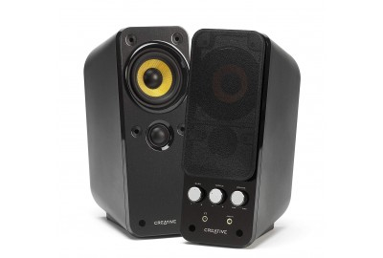

Tedber Speaker Wireless Bluetooth Stereo Subwoofer 800W

Brand: [Tedber](https://www.jumia.com.ng/deboss/)

**Price: $300**

Was ~~$500~~ 34%

+ shipping only for V.V.I.P clients.

Product details

1.Bluetooth version: Bluetooth3.0+EDR  
2. Hands-free communication function.  
3. TF card: Support  
4. Input plug: 3.5 mm signal input  
5. Output power: RMS2*5W  
6. Loudspeaker inverter tube: 2 PCS  
7. Frequency response: 100HZ---18KHZ   
8. Signal to noise ratio: ≥75dB   
9. Play format: MP3   
10. Built-in lithium battery: 3.7 V 2000mAh   
11. Power supply (USB): DC5V  
12. Shell: Plastic/ iron net  
13. Distance: about 10 meters in the open space  
14. Power supply mode: Built-in lithium battery  
15. Product size (W * D * H): about 40 * 5.5 * 6 cm/ 15.75 * 2.17 * 2.36 inches  
16. Gross weight: about 723 g

* Enhance your TV experience with crisp dynamic sound
* Wirelessly stream and enjoy music from your mobile devices, PC, tablet, or any other Bluetooth 3.0 enabled device.
* Listen to music straight from your USB drive with the MP3 Decoder.
* Wireless Bluetooth function: Built in Bluetooth, compatible with most Bluetooth devices, the range is widely which can use it under 10m/33feet, you can play your favourite music as you like.
* Built in 1800mAh Li battery, provides long battery life. Supports TF card.
* Slim speaker system and the technology packed inside can deliver a virtual surround sound experience.

Packing List:   
1 * Sound  
1 * Charging Cable  
1 * Audio Cable  
1 \***Packing Box**

* **Crisp dynamic sound**
* Wirelessly stream and enjoy music from your mobile devices
* Listen to music straight from your USB drive with the MP3 Decoder
* Wireless Bluetooth function
* Built in 1800mAh Li battery
* Supports TF card